
The Anthony Hall
London Road
Aston Clinton
HP22 5HG
Tel: 07928309321
manager@astonclintonpreschool.co.uk
acpscommittee@gmail.com
www.astonclintonpreschool.co.uk

Conflicts of interest
1 | Policy Statement………………………………………………………………………………………………………. | 1
2 | Types of Conflict of Interest………………………………………………………………………………………… | 1
3 | Authorisation for a trustee to receive a benefit………………………………………………………………….. | 2
4 | Procedure for dealing with conflicts of interest………………………………………………………………….. | 2
5 | Additional conditions relating to financial or material benefits……………………………………………….. | 3

1 Policy Statement
1.1 |  | Our trustees have a duty to act in the best interests of Aston Clinton Pre-school and must not use their position as a trustee to their own personal benefit.
1.2 |  | Conflicts of interest occur when a trustee’s personal interests, or the interests of an organisation or person connected to the trustee, have the potential to conflict with the interests of the charity.
1.3 |  | Trustees must avoid all situations that may possibly lead to a conflict of interest and also have a legal duty to declare any potential conflicts of interest between themselves (or a connected person or organisation) and the charity.
1.4 |  | Prior legal authorisation is also required in any situation where a trustee potentially stands to receive a material benefit from the charity.

2 Types of Conflict of Interest
 |  | A conflict of interest can arise for a trustee in situations where there is the potential for:
2.1 |  | - Direct financial gain or benefit involve a trustee receiving a direct financial gain or benefit, including:  - A paid employee of the charity becoming a trustee.  - Employing a trustee to work in a paid post within the charity.  - Paying a trustee, or an organisation which a trustee has a financial interest in, for services provided to the charity.  - Paying a trustee for work they carry out as part of their trustee duties.  - Selling charity equipment or land to a trustee.  - A trustee providing a loan to the charity.  - A waiver or reduction in care and education fees for a trustee.
2.2 |  | - Indirect financial gain can include the employment of a trustee’s partner by the charity, as the trustee may benefit indirectly from their partner’s salary.
2.3 |  | - Non-financial gain can include if a trustee is treated favorably when using the services of the charity, because they are a trustee, such as if they were given priority above other families when applying for care and education sessions.
2.4 |  | - Conflicts of loyalty or duty might arise for trustees if:  - A partner, relation or close friend is employed by the charity.  - They are a trustee, employee or member of another organisation that has dealings, or may be in direct competition, with the charity e.g. for a funding bid.

3 Authorisation for a trustee to receive a benefit
3 |  | Conflicts of interests are often created when a trustee stands to profit or personally benefit, either directly or indirectly, from the charity or their role. Explicit legal authority must be obtained from the governing document, the Charity Commission or a court of law before a trustee receives any financial or material benefit from the charity. There are limited circumstances where a benefit will not require authority i.e. reasonably incurred expenses. Benefits that are available to anyone and not just the trustees will also not generally need to be authorised. All benefits and payments to trustees are clearly detailed in the charity’s accounts.

4 Procedure for dealing with conflicts of interest
4.1 |  | - The charity maintains a trustee register of interests to help recognise potential conflicts of interest or loyalty for the trustees, recording information such as:  - Sources of significant income of the trustees (not including the amount).  - Significant business interests, including property holdings.  - Membership or board positions in other organisations.  - Significant participation in any form of a campaigning or political body.  - Details of any third parties that the trustee deals with on a regular basis.  - Relationships with any employees of the charity, or any potential employees, suppliers, service providers or funders to the charity.  - Situations where the trustee has the opportunity to benefit, including whether authority has been obtained.
4.2 |  | - Trustees are asked to complete a declaration of interests form, disclosing any known interests which may conflict with the work of the charity, on invitation to join the charity as a trustee and annually thereafter to keep the trustee register of interests up-to-date.
4.3 |  | - Significant interests for prospective trustees will be pointed out to the members at the time of trustee elections.
4.4 |  | - The trustee register of interests is used at each trustee meeting to identify any items for discussion where there is potential for a conflict of interest to arise for any of the trustees.
4.5 |  | - As not all conflicts of interest can be predicted in advance, trustees are asked to declare any potential conflicts of interests at the start of the meeting and must withdraw from any discussions and voting on the matter concerned.
4.6 |  | - To ensure transparency, the trustee is usually asked to leave the meeting at this point so that it cannot be claimed that they influenced the decision; although they may be asked to provide relevant information prior to this.
4.7 |  | - Where a trustee withdraws from discussions due to a conflict of interest, they are not included in the quorum; whether they leave the room or remain present. If this makes the discussion inquorate, voting and decision-making on the matter is postponed until the next quorate meeting.
4.8 |  | - The conflict of interest and the action taken are recorded in the minutes of the meeting.

5 Additional conditions relating to financial or material benefits
5.1 |  | - The trustees who do not stand to benefit from an arrangement make the decision over whether it is in the best interest of the charity for a trustee to receive a financial or material benefit. The matter is recorded on the trustee register of interests and the trustee concerned has no involvement.
5.2 |  | - In all cases where the trustees decide it is in the best interests of the charity, the trustees ensure they have the necessary legal authority before proceeding any further; making an application to the Charity Commission for authority in instances where the charity’s governing document does not provide this.
5.3 |  | - If legal authority is provided:  - The number of trustees receiving a financial or material benefit from the charity at any time, either directly or indirectly through a connected person or organisation, are always in the minority.  - A written agreement is drawn up to set out the arrangements between the trustee concerned and the charity, and is approved by the trustees who do not stand to benefit.  - Any payments or financial benefits made to a trustee are reasonable for the service provided and do not exceed the amount that would normally be paid by the charity.  - Trustees with a conflict of interest will not be permitted to sign contracts or invoices connected with the conflict.  - Trustees who receive a financial benefit from the charity do not hold one of the Officer positions, as implementing the procedures required to manage the conflict of interest will make it difficult to fulfil certain duties connected to these roles.  - The benefit is clearly recorded in the charity’s Annual Report and accounts.
5.4 |  | Each trustee is responsible for declaring any matters that may present any actual or potential conflict of interest. If any trustee is uncertain about what matters they should declare, they must raise the issue with the other trustees. Charity Commission advice and any actions taken in following the advice will be recorded in the minutes.
5.5 |  | The trustees must notify the Charity Commission if they find that a trustee is receiving an unauthorised benefit or has not acted in the best interest of the charity. In these cases, the trustee concerned may be in breach of trust and could be liable to repay the value of the benefit to the charity.
5.6 |  | Where a conflict of interest may damage the interests or reputation of the charity, the trustee may be asked to take steps to put an end to the situation causing the conflict; if necessary, by resigning as a trustee of the charity.

Policy Adopted by | Aston Clinton Preschool
On | …19th October 2024…….…………………………………………………………
Date to be reviewed | …19th October 2025.………………………………………………………………
Signed on behalf of the provider | 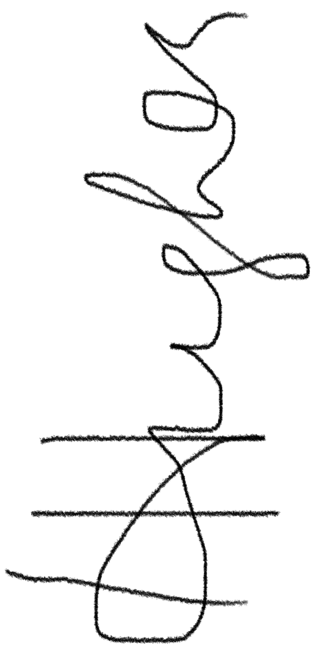………………………………………………………
Name of signatory | Hannah Hughes………………………………………………………
Role of signatory | …Committee Chairperson……………………

