
The Anthony Hall
London Road
Aston Clinton
HP22 5HG
Tel: 07928309321

manager@astonclintonpreschool.co.uk
acpscommittee@gmail.com
www.astonclintonpreschool.co.uk

1.7 Whistleblowing

1 | Policy Statement……………………………………………………………………………………………………….. | 1
2 | Procedures………………………………………………………………………………………………………………. | 1

1 |  | Policy statement  Whistle blowing encourages and enables employees and committee volunteers to raise serious concerns within the organisation of Aston Clinton Pre School rather than overlooking a problem or “blowing the whistle outside”. Aston Clinton Pre School is committed to the highest possible standards of openness, probity and accountability. In line with that commitment we expect employees, and others that we deal with, who have serious concerns about any aspect of our work to come forward and voice their concerns.  By using this policy, we aim to:  - Provide avenues for relevant parties to raise concerns in confidence and receive feedback on any action taken.  - Ensure that they receive a response to their concerns and that if they are aware of how to pursue them if they are not satisfied.  Reassure them that they will be protected from possible reprisals or victimisation if they have a reasonable belief that they have made a disclosure in good faith
2 |  | Procedures  - As a first step any concerns should be raised verbally or in writing to the group immediate supervisor/manager. This will be dependent on the seriousness and sensitivity of the concern, for example if it believed the concern is in direct relation to the line manager, a more serious management level or the chairperson of the committee
Policy Adopted by |  |  | Aston Clinton Preschool
On |  |  | …19th October 2024…….…………………………………………………………
Last Review Date |  |  | ….19th October 2024
Date to be reviewed |  |  | …19th October 2025..……………………………………………………………
Signed on behalf of the provider |  |  | 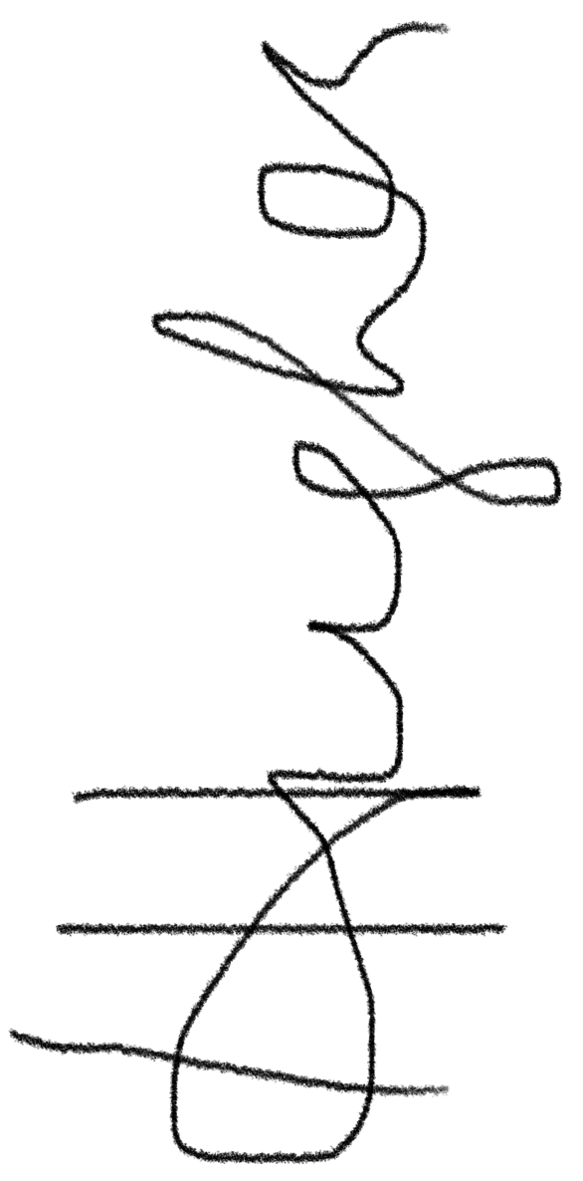  ……………………………………………………………………………………………
Name of signatory |  |  | Hannah Hughes……………………………………………………

