The Anthony Hall
London Road
Aston Clinton
HP22 5HG
Tel: 07928309321
manager@astonclintonpreschool.co.uk.
acpscommittee@gmail.com
www.astonclintonpreschool.co.uk


8.5 Tapestry Policy
1 | Policy Statement……………………………………………………………………………………………………….. | 1
2 | Procedures………………………………………………………………………………………………………………. | 1
3 | Legal Framework……………………………………………………………………………………………………….. | 2
4 | Further Guidance………………………………………………………………………………………………………. | 2

1 |  | Policy statement  Aston Clinton Pre-school ensures that all children attending the setting have a personal Learning Journey which records photos, observations and comments, in line with the Early Years Foundation Stage, to build up a record of each child’s achievements during their time with us.  At Aston Clinton Pre-school we use an online system called Tapestry to record and store all observations and assessments relating to each child. This is a safe and secure system and one that enables parents and carers to access their child’s learning journey at any time.
2 |  | Procedures  - Each child will have an Early Years Key worker allocated to them who will be responsible for the compilation of that child’s Learning Journey.  - Parents/carers logging into the system are only able to see their own child’s Learning Journey.  - Parent/Carer access allows for them to comment (or ‘reply’) to observations that staff have written. There is also the possibility for parents/carers to add their own observations and photos/videos. Any observations the parents/carers add will be approved and added into the journal by the staff to ensure appropriate content.  - Staff access to the system allows input of new observations and photos or amendment of existing observations and photos.  - Where necessary observations input into the Tapestry system are moderated by a senior member of staff before being added to the child’s Learning Journey.  - A child’s learning journey is a document recording their learning and development and parents may add comments on observations or contribute photos, videos or information about activities they have been doing at home.  - Observations are regularly monitored by the managing staff and assessed during staff meetings to ensure they are providing relevant and informative information.
3 |  | Security  - Staff will be allocated time at work to update journals and assess their key children’s next steps.  - Staff may need to work on journals at home. Staff are not permitted to download any photographs of the children onto their own devices. If staff do work on Tapestry at home, they should be aware of any other people around them and make sure they are not overlooked. They must logout as soon as they have stopped working.  - If any member of staff suspects that their login details have been compromised in any way, they must inform the pre-school managers and new login details will be created.  - Parents are asked to sign a consent form giving permission for their child’s image to appear in other children’s Learning Journeys, and to protect images of other children that may appear in any photos contained in their child’s Learning Journey.  - The Tapestry on-line Learning journey system is hosted on secure dedicated servers based in the UK.  - Access to information stored on Tapestry can only be gained by unique user id and password.  - Parents can only see their own child’s information and are unable to login to view other children’s Learning Journeys.  - Parents and staff are not permitted at anytime to either download/screenshot or photograph their child’s observation and share it digitally or through social media.
4 |  | When children leave the setting  - When children leave our setting the information on Tapestry can be transferred to the new setting if they are using Tapestry.  - If not, the learning journal can be downloaded as a PDF document.

Policy Adopted by | Aston Clinton Preschool
On | …04th November 2022……………………………………
Last Review Date | ….19th October 2024
Date to be reviewed | 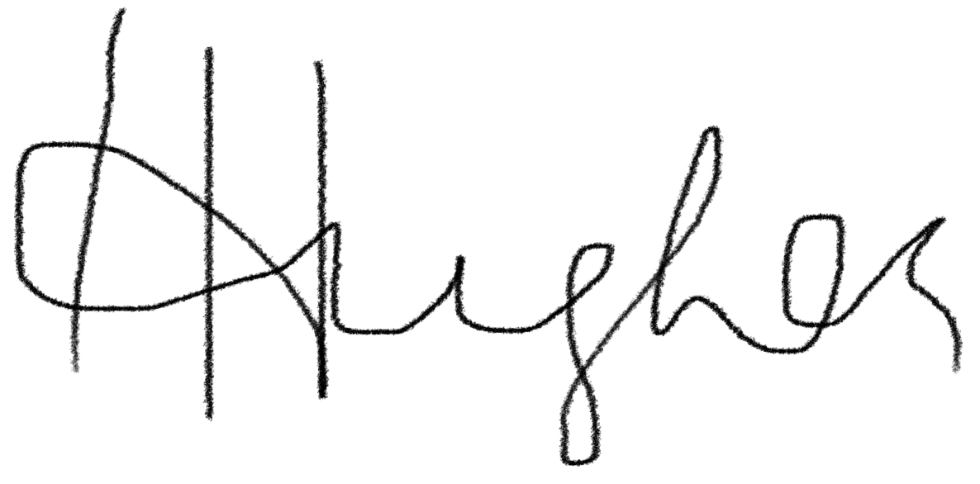  …19th October 2025.…………………………
Signed on behalf of the provider | ……………………………………………………………………
Name of signatory | Hannah Hughes …………………………………………

