The Anthony Hall
London Road
Aston Clinton
HP22 5HG
Tel: 07928309321
manager@astonclintonpreschool.co.uk
acpscommittee@gmail.com
www.astonclintonpreschool.co.uk

3.7 Staff Grievance Policy
1 | Purpose………………………………………………………………………………………………………………….. | 1
2 | Scope………………………………………………………………………….…………………………………………. | 2
3 | Definition………………………………………………………………………………………………………………… | 3
4 | Procedure………………………………………………………………………………………………………………... | 3
4.1 | Informal Process……………………………………………………………………………………………………….. | 3
4.2 | Formal Process…………………………………………………………………………………………………………. | 3
4.3 | Appeal Process…………………………………………………………………………………………………………. | 4
5 | Guidelines………………………………………………………………………………………………………………..
6 | Absence during the procedure……………………………………………………………………………………….
7 | Mediation…………………………………………………………………………………………………………………
8 | Former employees………………………………………………………………………………………………………
9 | Related policies and documents……………………………………………………………………………………..

Purpose

The objective of our grievance policy is to provide all employees and workers with the opportunity to raise a grievance concerning work-related matters and to enable our managers to deal with these in a manner that is fair and consistent, whilst aiming to maintain harmonious employee relations in the long term.

We recognise that from time to time individuals may have a concern relating to their employment. We encourage open discussion between them and their managers to ensure that any questions and problems are aired and resolved as quickly as possible.

Generally, most concerns will be resolved as they arise by employers and workers talking to their managers. However, where there is a more serious concern, or one that is not readily resolved, the procedure to follow is outlined below. We encourage the use of the formal procedure if the individual is unable to resolve the problem through their day to day working relationship with their manager. The procedure should be followed as quickly as possible to ensure issues are resolved in a timely manner.

In raising a grievance, the concern or issue should be current and not something that occurred in the past, unless it is a repeat of an earlier incident. The focus of the grievance procedure is to achieve resolution, not to apportion blame.

We will treat all matters as confidential between our employees and any individuals directly involved in the process. Any witness statements and decisions will be kept confidentially and in accordance with data protection legislation.

This policy is not contractual, but aims to set out how we normally deal with such issues although we reserve the right at our discretion to vary or replace the procedure at any stage.

Scope

This policy and procedure applies to all employees and workers, including managers and directors, those who are still within their probationary periods, and those on casual contracts. It does not apply to agency workers or self-employed contractors.

The procedure set out below does not apply if the grievance relates to an appeal in connection with disciplinary action: in this case our disciplinary policy should be followed. However, if an employee or worker believes that they are subject to conduct or capability related disciplinary action which is unlawfully discriminatory, or feels that the action is being taken for reasons other than conduct or capability, they should use this grievance procedure rather than appealing within the disciplinary procedure. In such cases, the disciplinary process will normally be suspended whilst the grievance is investigated and resolved.

If the grievance relates to bullying/harassment, our bullying and harassment policy may be more appropriate.

Definition

Grievances are concerns, problems or complaints that are work-related. They may relate to action which has already been taken or which is contemplated in relation to an employee or worker, or may include the actions of third parties such as colleagues. They may relate to a wide range of issues including, but not limited to, terms and conditions of employment (or their perceived unfair or inconsistent application), health and safety, work relations, new working practices, working environment, organisational change, equal opportunities or bullying/harassment.

Procedure

Informal process

Employees and workers should attempt to resolve their grievances informally prior to instigating formal procedures, and as soon after the matter about which they are aggrieved has occurred. It is anticipated that most issues will be resolved informally in the first instance, through discussion with the Pre School-Manager.

Where a grievance concerns the behaviour of, or decisions taken by the individual’s manager, they should raise the issue with the Chair of the Governing Committee.

Formal process

To instigate the formal process, the individual should submit their grievance in writing. This should be dated and detail what the grievance is about, who and what it concerns, as well as how they think it can be resolved. This should be sent to the Chair of the Governing Committee.

A formal meeting will be arranged as soon as possible to discuss the grievance.

The individual may bring either a work colleague, a trade union representative (who must be certified in writing by the union as having experience of, or having received training in, acting as a worker's companion at disciplinary or grievance hearings) or an official employed by a trade union as a companion to the meeting, in which case we request that they advise us of the identity of their chosen companion in advance of the meeting.

At the meeting, the person hearing the grievance will review the grievance submitted and listen to the individual’s point of view. If the employee or worker has not stated what outcome they are seeking, clarification may be sought before proceeding.

Where appropriate it may be necessary to call witnesses, or speak to third parties to fully investigate and understand the issues. For this reason, most grievance meetings will be adjourned once the employee or worker has been given full opportunity to state his/her case, present any additional information and answer any questions. No decision will be made until the chair of the meeting has sufficient information and evidence.

Once the person chairing the grievance meeting has sufficient information and has reviewed the case they will prepare a response in writing. We will also confirm any action we intend to take to resolve the grievance, together with the right to appeal against this outcome. This written response will be provided as soon as possible.

Appeal process

If the employee or worker is dissatisfied with the outcome of the meeting, then they may appeal. Appeals should be lodged, preferably in writing, and stating the full grounds for the appeal, within five working days of receipt of the outcome letter to the Chair of the Governing Committee. The person to whom the appeal should be sent will be set out in the outcome letter.

Failure to appeal within the stated timescale may mean that the appeal will not be heard. It will only be heard outside of this time frame in exceptional circumstances.

A further meeting will be arranged as soon as is reasonably practicable to hear the appeal. Again, the individual will be given full opportunity to state the case, provide further information and answer questions.

The person chairing the appeal meeting will attempt to resolve the matter to the satisfaction of both the individual and the company.

The employee or worker may bring either a work colleague, a trade union representative (who must be certified in writing by the union as having experience of, or having received training in, acting as a worker's companion at disciplinary or grievance hearings) or an official employed by a trade union as a companion, but in which case we request that they advise us of the identity of the chosen companion in advance of the meeting.

Once the person chairing the appeal meeting has reviewed the case, they will either advise the individual at the meeting as to the outcome or prepare a response in writing after the meeting.

This is the final step in the process and any decisions taken at this stage are final.

Guidelines

At all formal stages of this procedure, the person chairing a grievance meeting is advised to be accompanied by a suitable management representative who will act as a witness and take full notes of everything that is said. Where no internal person of sufficient seniority or confidential status is available, or where preferred, an external party may be invited to attend in this capacity.

The individual raising the grievance should make every effort to attend the meeting. If, however they or their chosen companion is unable to attend any meeting under this procedure for a reason which was not foreseeable at the time the meeting was arranged, we will attempt to rearrange the meeting for a date within five working days of the original scheduled date.

The employee or worker raising the grievance should tell the person conducting the meeting in advance who they have chosen as a companion. If the employee does not wish to be accompanied this should be noted. Fellow workers may not be compelled to attend as a companion. The companion is there to act as a witness to what was said, to provide moral support and to assist and advise the person in presenting their case. He or she may address the meeting (provided the person wishes this), ask questions on their behalf and confer with the individual raising the grievance but not answer questions on their behalf. The companion is also not permitted to prevent us from explaining our case.

The timing and location of meetings will be reasonable and we will aim to ensure that the procedure is followed without unreasonable delay. Meetings will be confidential, and wherever possible will be held in a private location and without interruptions.

At the grievance meeting, the individual raising the grievance will be invited to re-state the grievance and explain how they would like it to be resolved. Full opportunity will be provided to present any information and answer questions before any decision is made.

The person conducting the meeting may adjourn it at any stage to calm a tense situation, to investigate further or take advice. We will not tolerate abusive or insulting behaviour from anyone taking part in or conducting grievance procedures and may treat any such behaviour as misconduct under the disciplinary procedure.

Reasonable adjustments will be made to ensure that any disabled individual is not disadvantaged in any way at the meeting. They should inform us of any requirements (eg for a signer or other support) where necessary. Arrangements may also be made to assist any person who does not have English as his or her first language and who may need an interpreter.

To ensure that any issue raised is resolved effectively, all parties should aim to:
- focus on the facts and ignore rumours or hearsay
- limit the issue to those involved and show discretion at all times
- work only to resolve the issue and actively pursue a positive outcome
- be honest about their own role and involvement
- demonstrate understanding, empathy and flexibility to ensure that the other person's perspective is accommodated
- strengthen relationships once the outcome is known and positively apply any learning points for the future.

When considering a suitable resolution, the person chairing the grievance meeting will consider whether similar grievances have been raised before, how they have been resolved and any follow-up action that was taken.

Notes will be made of all meetings held under the grievance procedure, with one copy being given to the person raising the grievance and one being kept on file. Such documents will be regarded as confidential.

If a grievance made against another employee is proven to have been frivolous or raised without good cause, the disciplinary policy will apply.

Absence during the procedure

We recognise that grievances can be stressful for both the person raising the grievance and for any other employees against whom a complaint is made. However, we believe that in most cases this stress is best alleviated, and working relationships maintained, by completing the grievance procedure quickly.

Where an employee or worker is unfit for work, this does not necessarily mean they are unfit to attend an investigatory meeting or a grievance meeting and employees must make every effort to co-operate with us in completing the grievance process.

If the employee or worker is absent due to illness or other reasons such as maternity/adoption/paternity/shared parental or other leave, we will consider, in consultation with the employee (and/or his GP, as appropriate, in the case of illness), whether there are any reasonable adjustments that can be made to enable the case to be progressed (eg by allowing the employee to make further written submissions, by conference call or by holding the meeting at a different venue).

If, after an attempt to contact the employee or worker, we reasonably believe that they are unlikely to be able to attend a meeting in the near future or to provide any further information, we may decide the matter without the employee or worker's further input, based on the evidence and information available to us. Unless the employee has already been informed of this, we will write to inform the employee of our intentions to proceed in their absence before taking any decisions.

Mediation

Mediation may be considered as an appropriate alternative method of resolving any differences between employees and workers. Where mediation is introduced before or during the grievance process, all parties will be asked to confirm in writing that they agree to the grievance process being adjourned whilst mediation is being undertaken. Should mediation prove unsuccessful, the grievance process will be resumed; where it is successful, the grievance will be regarded as resolved.

Former employees

Former employees may also raise grievances at any time up to three months after their employment has ended. In such cases, we would normally ask that they set out the details of their grievance in writing, ensuring that this is dated and states that they are making a formal grievance. We will then respond in writing without the need for a grievance meeting and without a further right of appeal.

However, if the complaint relates to dissatisfaction with a dismissal decision, an appeal should be made against that decision in accordance with the appeal process set out in our disciplinary policy, rather than invoking the grievance procedure.

Related policies and documents
- Bullying and harassment policy
- Disciplinary policy
- Equal opportunity policy
- Whistleblowing policy
The above list is not exhaustive.

Policy Adopted by |  | Aston Clinton Preschool
On |  | …19th October 2024…….…………………………………………………………
Last Review Date |  | ….19th October 2024
Date to be reviewed |  | …19th October 2025..………………………………………………………………
Signed on behalf of the provider |  | 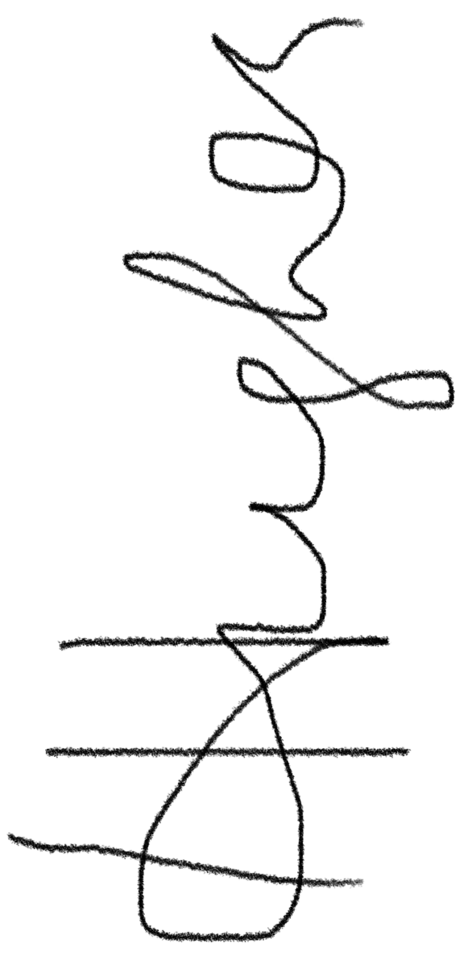…………………………………………………………………
Name of signatory |  | Hannah Hughes …………………………………………………………
 | Role of signatory |  | …Committee Chairperson……………………….……………………………

