
The Anthony Hall
London Road
Aston Clinton
HP22 5HG
Tel: 07928309321

manager@astonclintonpreschool.co.uk
acpscommittee@gmail.com
www.astonclintonpreschool.co.uk

4.4 Nappy changing

1 | Policy Statement……………………………………………………………………………………………………….. | 1
2 | Procedures………………………………………………………………………………………………………………. | 1

1 |  | Policy statement  No child is excluded from participating in our setting who may, for any reason, not yet be toilet trained and who may still be wearing nappies or equivalent. We work with parents towards toilet training, unless there are medical or other developmental reasons why this may not be appropriate at the time.  We provide nappy changing facilities and exercise good hygiene practices in order to accommodate children who are not yet toilet trained.  We see toilet training as a self-care skill that children have the opportunity to learn with the full support and non-judgemental concern of adults.
2 |  | Procedures  - We have a list of those children who are in nappies or ‘pull-ups’; and change nappies according to this as frequently as is necessary.  - All staff are responsible for ensuring that nappies are monitored and changed during the course of the day or as and when it is required.  - Children are changed within sight of other staff whilst maintaining their dignity and privacy at all times.  - Our staff put on gloves and aprons before changing starts and the areas are prepared.  - All our staff are familiar with our hygiene procedures and carry these out when changing nappies.  - Our staff never turn their back on a child or leave them unattended whilst they are on the changing mat.  - We are gentle when changing; we avoid pulling faces and making negative comments about ‘nappy contents’.  - We do not make inappropriate comments about children’s genitals when changing their nappies.  - In addition, we ensure that nappy changing is relaxed and a time to promote independence in young children.  - We encourage children to take an interest in using the toilet.  - We encourage children to wash their hands, and have soap and towels to hand. They should be allowed time for some play as they explore the water and the soap.  - Older children access the toilet when they have the need to and are encouraged to be independent.  - We dispose of nappies and pull-ups hygienically. The nappy or pull-up is bagged and put in the nappy bin. Cloth nappies, trainer pants and ordinary pants that have been wet or soiled are bagged for parents to take home.  - We have a ‘duty of care’ towards children’s personal needs. If children are left in wet or soiled nappies/pull-ups in the setting, this may constitute neglect and will be a disciplinary matter.
Policy Adopted by |  |  | Aston Clinton Preschool
On |  |  | …04th November 2022…….…………………………………………………………
Last Review Date |  |  | ….19th October 2024
Date to be reviewed |  |  | …19th October 2025..………………………………………………………………
Signed on behalf of the provider |  |  | 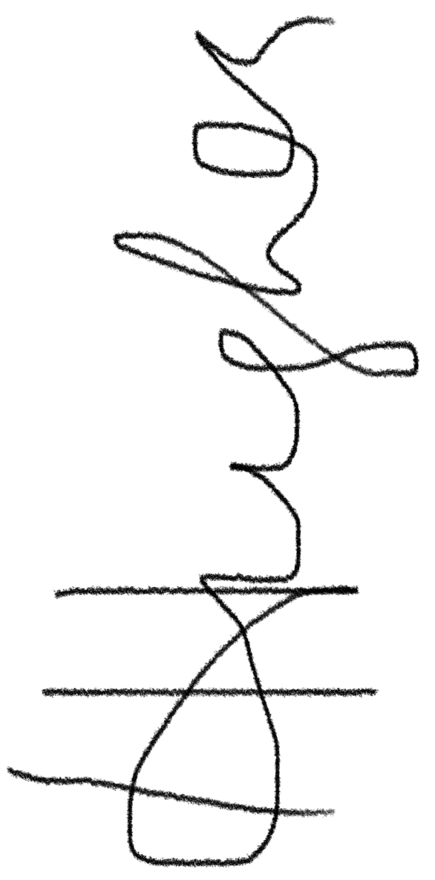……………………………………………
Name of signatory |  |  | Hannah Hughes ……………………………………………………
Role of signatory |  |  |  | …Committee Chairperson……………………….……………………………

